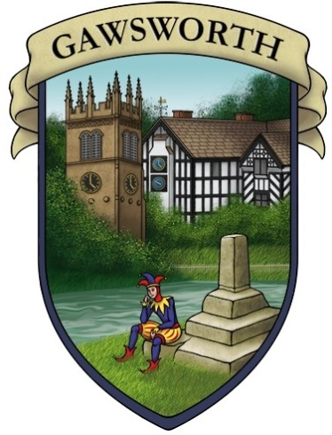
Gawsworth Parish Council
Parish Clerk: Adam Keppel-Green BSc BA FSLCC
Squirrel Brook, 68 Manor Park South, Knutsford, WA16 8AN
clerk@gawsworthpc.org.uk 07584 057 228
www.gawsworthpc.org.uk

APPLICATION FOR CO-OPTION
Form to be returned to the Parish Clerk. The information on this form (excluding your contact information) will be published publicly for the meeting at which co-option is being considered.

Personal Details and Contact Information
Title: |  | Full Name:
Address: |  |  | E-mail :
Address: |  |  | Phone:
 |  |  | Mobile:
 |  |  | Postcode:
How long have you lived in Gawsworth?
Do you meet the qualification criteria? |  |  | Yes |  | No

Tell us a little about you and the experience/perspective you’ll bring to the council

Why do you want to join Gawsworth Parish Council

What would you like to achieve as a councillor?

Working Groups
The Parish Council has a number of working groups which further projects or work in depth on proposals for Parish Council meetings. Which (if any) of the following would you be interested in being part of:
Footpaths
Park and Woodland
Communications
Green Gawsworth Strategy

